**Face mask and social distancing detection**

**Team**

* Ayush N Patel (190907662)
* Kotla Ujwal Reddy (190907664)
* Yash Agarwal (190907580)
* Aravind (190907304)

**Objective**

To design a deep learning model that can detect if a person is wearing a face mask and if two adjacent people are following social distancing norms.

**Methodology**

* Detect faces
* Calculate distance between each face
* Mask detection on detected faces

**Process Flow**

**Process Flow**

1. Three datasets are to be used, they are:
   1. Haar[1] cascade database[2] for face detection
   2. A training and validation database[3] for mask detection
   3. A test database[4] for testing mask detection and social distancing violation
2. First, the database is run through a haar[1] cascade model to detect faces.
3. If more than one face is detected, the faces in those images are iterated over and the distances[5] between them are calculated.
4. If social distancing violations are detected (<6ft), a visual alert is thrown.
5. The faces detected and the distances calculated are appended to a dictionary to be referenced later.
6. Post successful face detection and distance calculation, the images along with the dictionary are sent through to a mask detection model that is to be trained on an existing Kaggle database.
7. Final output image returns an image with the detected faces, distances between each face and if they are wearing a mask, overlayed on the original image.

**Code**

* Importing necessary libraries



* Importing haar cascade file for frontal face detection



* Plotting a box around the detected faces and trying the computation on a sample image



* Checking for social distancing violations



**Sample Outputs**

* Face detection

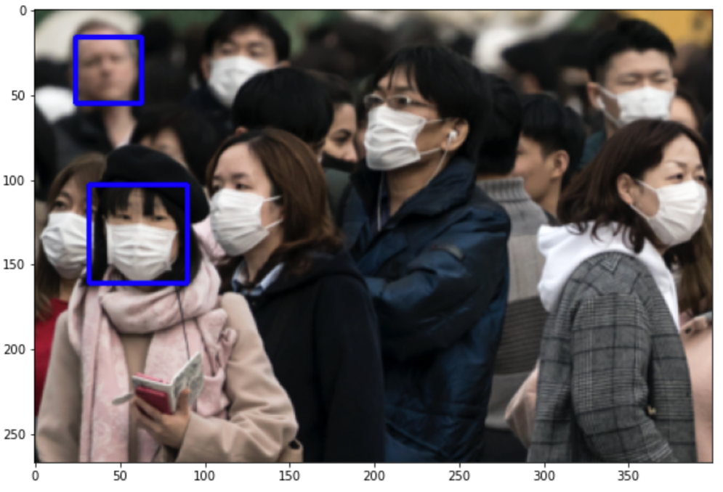

**Figure 1.1 – Sample image 257**

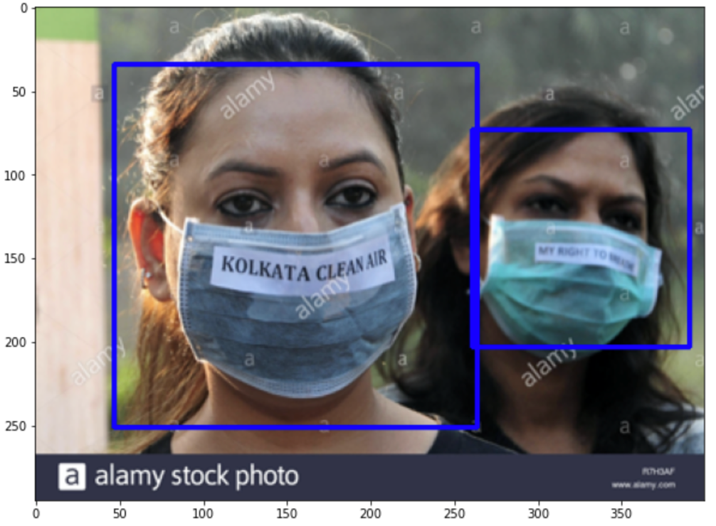

**Figure 1.2 – Sample image 269**

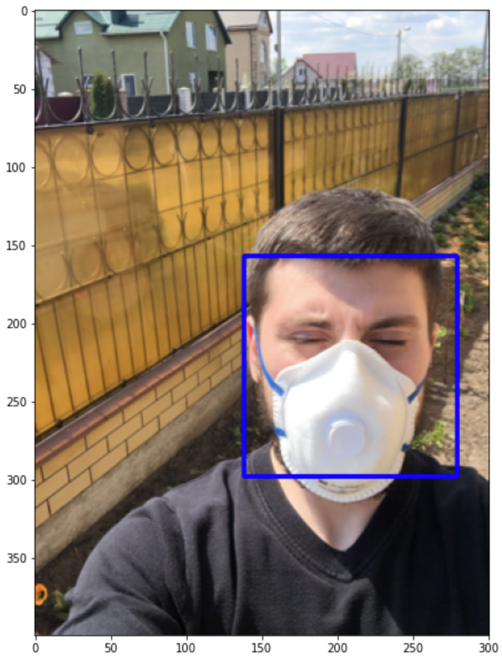

**Figure 1.3 – Sample image 262**

* Social distancing detection

(Step2, post face detection)

*(Green indicates no violation of social distancing; Red indicates a violation of social distancing)*

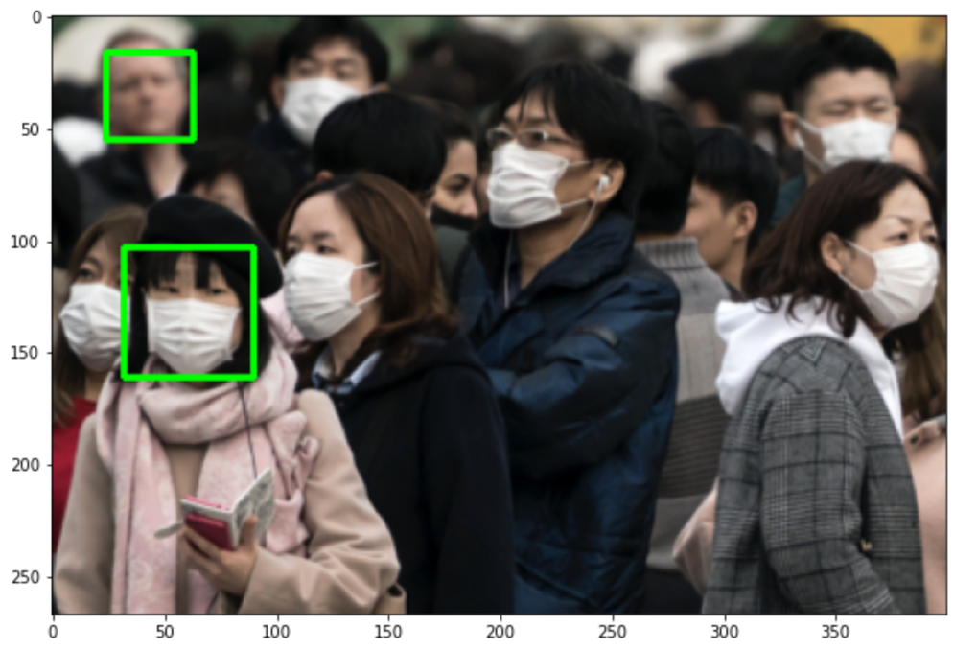

**Figure 2.1 – Sample image 257**

**Figure 2.2 – Sample image 269**



**Figure 2.3 – Sample image 262**

**Roadmap**

To search and implement a suitable model for detection of face mask to work in conjunction with the haar and distance detector.

**References**

[1] P. Viola; M. Jones “Rapid object detection using a boosted cascade of simple features” in Proceedings of the 2001 IEEE Computer Society Conference on Computer Vision and Pattern Recognition. CVPR 2001, 15 April 2003

[2] “Haar Cascades for Face Detection” kaggle.com

<https://www.kaggle.com/datasets/gpreda/haar-cascades-for-face-detection> (accessed Sept. 20, 2022)

[3] “Face Mask Detection ~12K Images Dataset” kaggle.com

<https://www.kaggle.com/datasets/ashishjangra27/face-mask-12k-images-dataset> (accessed Sept. 29, 2022)

[4] “Face Mask Detection” kaggle.com

<https://www.kaggle.com/datasets/andrewmvd/face-mask-detection> (accessed Sept. 29, 2022)

[5] “OpenCV Social Distancing Detector” pyimagesearch.com

<https://pyimagesearch.com/2020/06/01/opencv-social-distancing-detector/> (accessed Oct. 1, 2022)